ASSIGNMENT 2
DATA CLEANING AND ESSENTIAL FUNCTIONS
Q1. What is data cleaning, and why is it important in data analysis?
. What are the essential consequences of analyzing unclean or messy data.
. Explain the common steps involved in cleaning and organizing data.
Ans: Data cleaning is very important in data analysis because it help to find meaningful insights and correct analysis of the data.
Consequences:
- Wrong outputs
- Wrong analysis
- Misleading insights
- Duplicate values will be counted doubled
Common steps involved in cleaning and organizing data
- Filtering and sorting
- Removing errors and blanks
- Apply data validation
- Correct format
- Split data using text to columns
Q2. How would you sort the following data first by “Departments” (A-Z) and then by “Salary” (Largest to Smallest)? Write a step-by-step approach
Ans : Sorting by “Departments” (A-Z)
Steps:
- Select the data.
- In home tab click on sort & filter.
- Click on filter
- Then sort department from (A-Z)
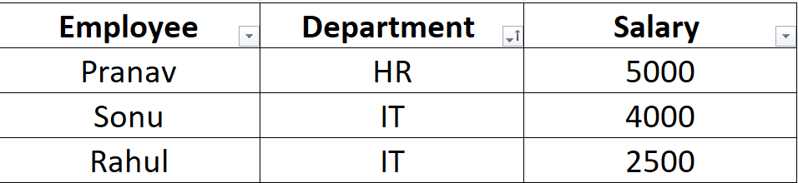

Sorting by “Salary” (Largest to Smallest)
- Select the data.
- In home tab click on sort & filter.
- Then click on filter.
- Apply filter on “Salary”.
- Sort largest to smallest.
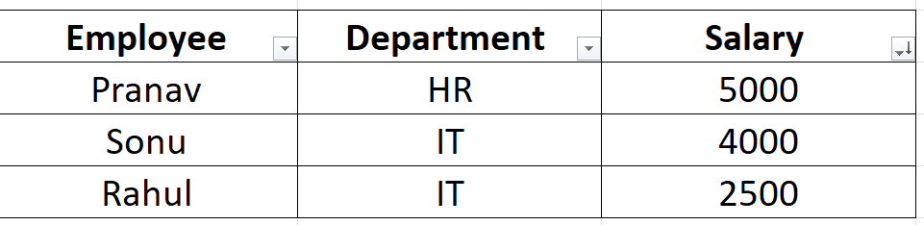
NOTE: TWO FILTERS CANNOT WORK OR APPLY TOGETHER ONE FILTER WILL WORK AT A SINGLE TIME
Q3. Explain the use of text functions such as TRIM,LEFT,RIGHT,MID and CONCAT in data cleaning.
Ans: Trim Function: it is used to trim the unusual space from the starting of the text or ending of the text.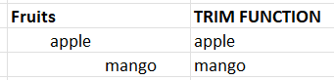
Left function: it is used to find the left side characters of the string.
Right function: it is used to find the right side characters of the string.
Mid function: it is used to find the middle characters of the string.
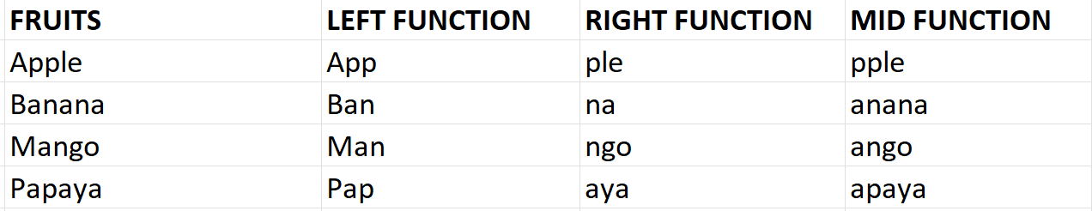
Concat function: it is used to combine two or more text values.
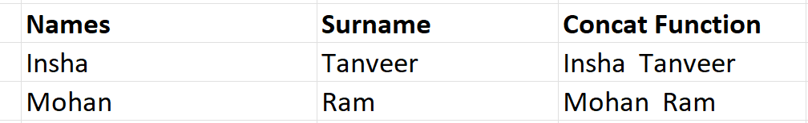
Q4. What is the role of date functions like TODAY in managing datasets?
Ans: TODAY () is used to find the current date in the dataset to do calculations on date based.
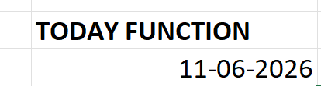
Q5. Apply Data validation to restrict Quantity values to only whole numbers 1 and 10.
- Configure an input message that appears when a user selects a cell in the “quantity” column explaining:
“Please enter a whole number between 1 and 10”.
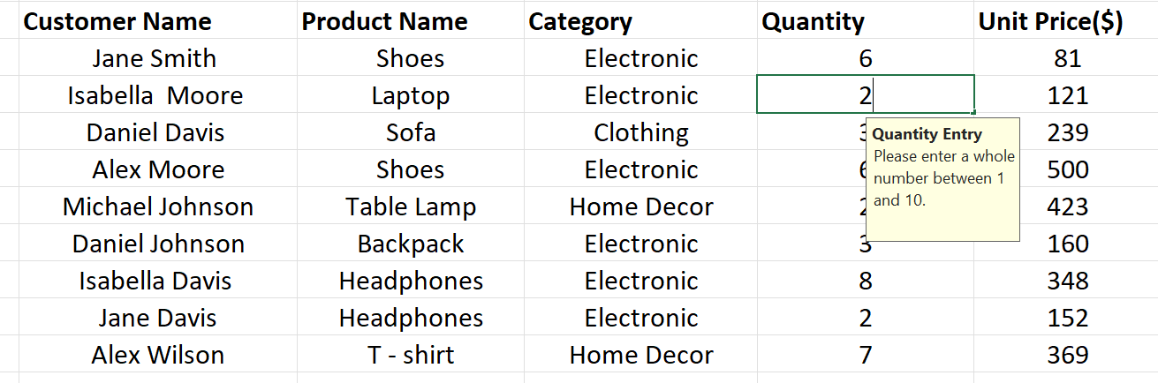
- Setup an error alert message that triggers if the user enters a number less than 1 or greater than 10, showing:
“Invalid Input! The Quantity must be a whole number between 1 and 10”

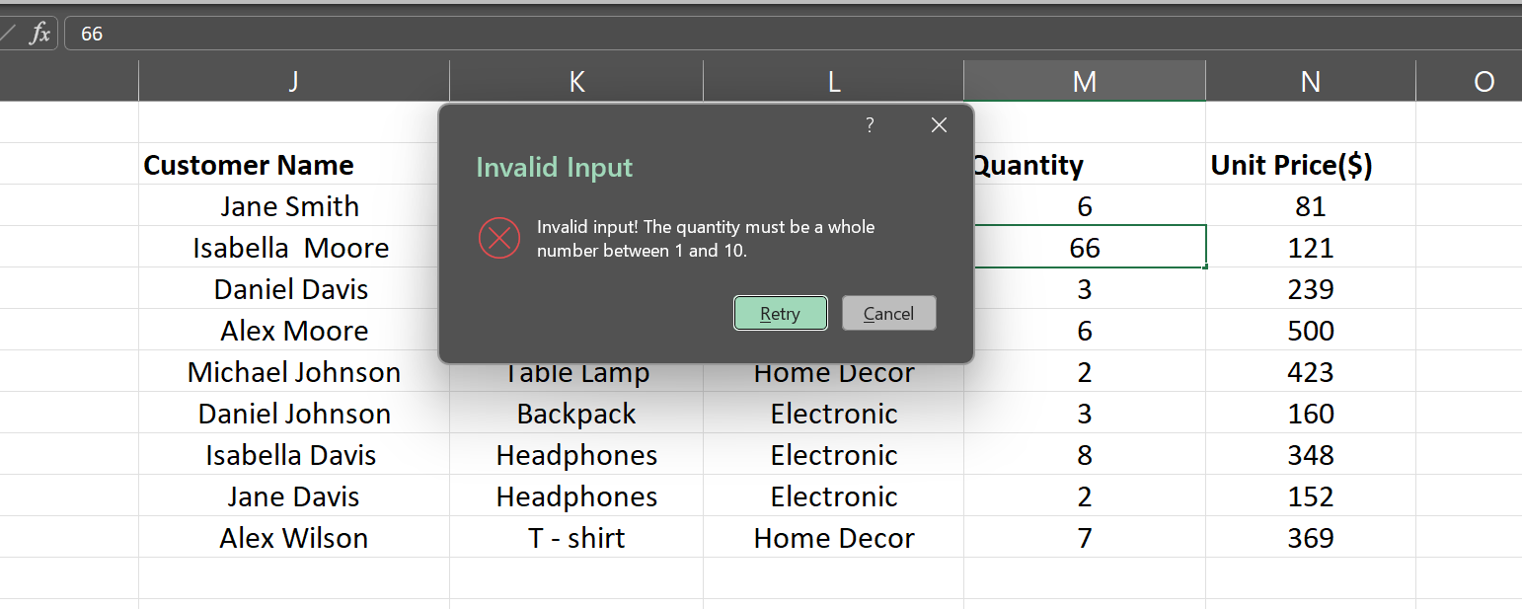

Q6. Understand and apply fundamental text functions like Left, Right, Mid, Len.
.Extract the first 5 characters from the string “ExcelTipsAreGreat” using the Left Function.
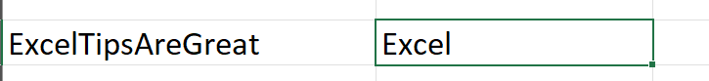
. Extract the last 4 characters from “DataAnalysis.xlsx” using the Right function.
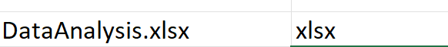
. Extract the substring “Tips” from “ExcelTipsAreGreat” using Mid function.
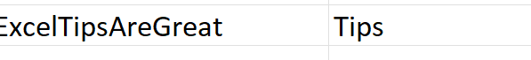
. Count the total numbers of characters in the string “Hello World!” using the Len function.
. Create a formula to extract the middle 6 characters from “12345-67890-ABCDE”.
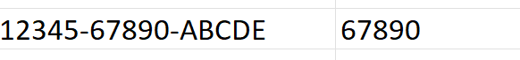
Q7. Understand how to combine text using CONCAT, TEXT JOIN, and the & operator.
- Use CONCAT to combine “Hello” and “World” with a Space in between.
- Combine “Apple”, “Banana”, and “Cherry” into a single string separated by commas using TEXT JOIN.
- Use the & operator to create the string “2025:Excel Functions” by combining “2025”,”:”, and “Excel Functions”.
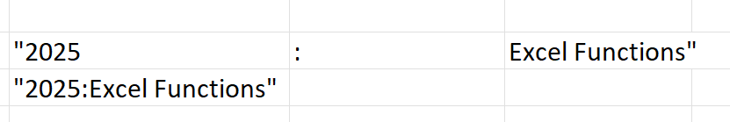
- Create a comma-separated list from the range A1:A5 using TEXT JOIN.
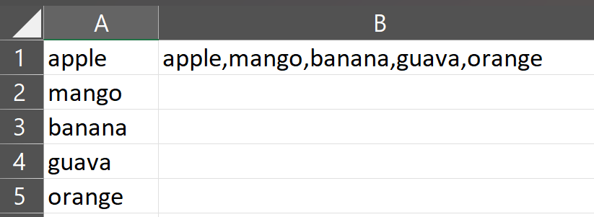
- Combine first names in column A with last names in column B to create full names in column C.
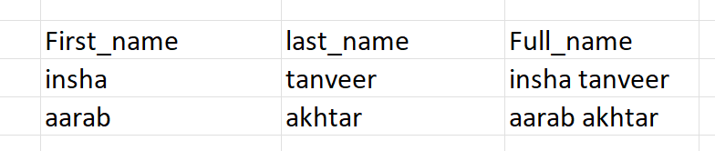
Q8. Understanding TODAY () and Now ()
- What is the difference between TODAY() and NOW() in Excel? Provide an example of when you would use each function .
TODAY() is used to find the present date
Eg:
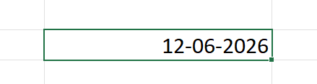
NOW() is used to find the current date with current time in IST.
Eg:
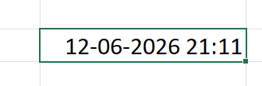
- If cell A1 contains the date 2025-06-10 , write a formula using TODAY() to determine how many days are left until that date.
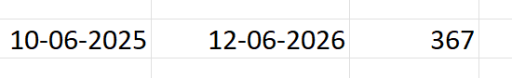
- Write an Excel formula using NOW() to display the current date and time in the format MM/DD/YYYY HH:MM AM/PM’.

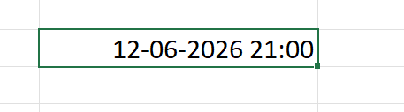
- If a cell contains = TODAY(), what will happen when the worksheet is reopened the next day?explain.
If we use the TODAY () for present day the next day we reopened the worksheet the date will automatically will be updated for the next day.
- You want to store a static date (today’s date ) in a cell without it changing everyday . what keyboard shortcut should you use?
To make a date static in a cell without changing everyday we will use Ctrl + ; keyboard shortcut key is been used.

